**Final project**

**Introduction**

With the constant evolution of streaming services, Netflix has established itself as an icon of culture. Our analysis uses Netflix's massive dataset to uncover trends in content availability and use, with an audience that includes academic researchers, corporate strategists, and movie enthusiasts. For anyone trying to determine audience preferences and the strategic future of digital entertainment platforms, these data are essential.

**Agenda**

This document outlines the dashboards and storyboards created by our team using the Netflix dataset.

**Analysis of dashboards and storyboards**

**Dashboard**

The dashboard provides a thorough overview of Netflix's content, with a noticeable focus on mature audiences and a large amount of TV-MA programming, suggesting that the platform is aimed at adult users. International dramas and documentaries are both heavily represented, which attests to the platform's commitment to a variety of genres with broad appeal. The visual distribution on a global map highlights Netflix's reach, especially in regions that are more heavily lit by titles, indicating deliberate market involvement. The data is noteworthy since it shows that there are more movies than TV series, with a peak in content availability around 2020. This could be attributed to either purposeful content acquisition or customer desire.

For stakeholders looking to comprehend viewing patterns, market share, and content strategy, this report is essential since it offers insightful information on Netflix's place in the streaming industry.

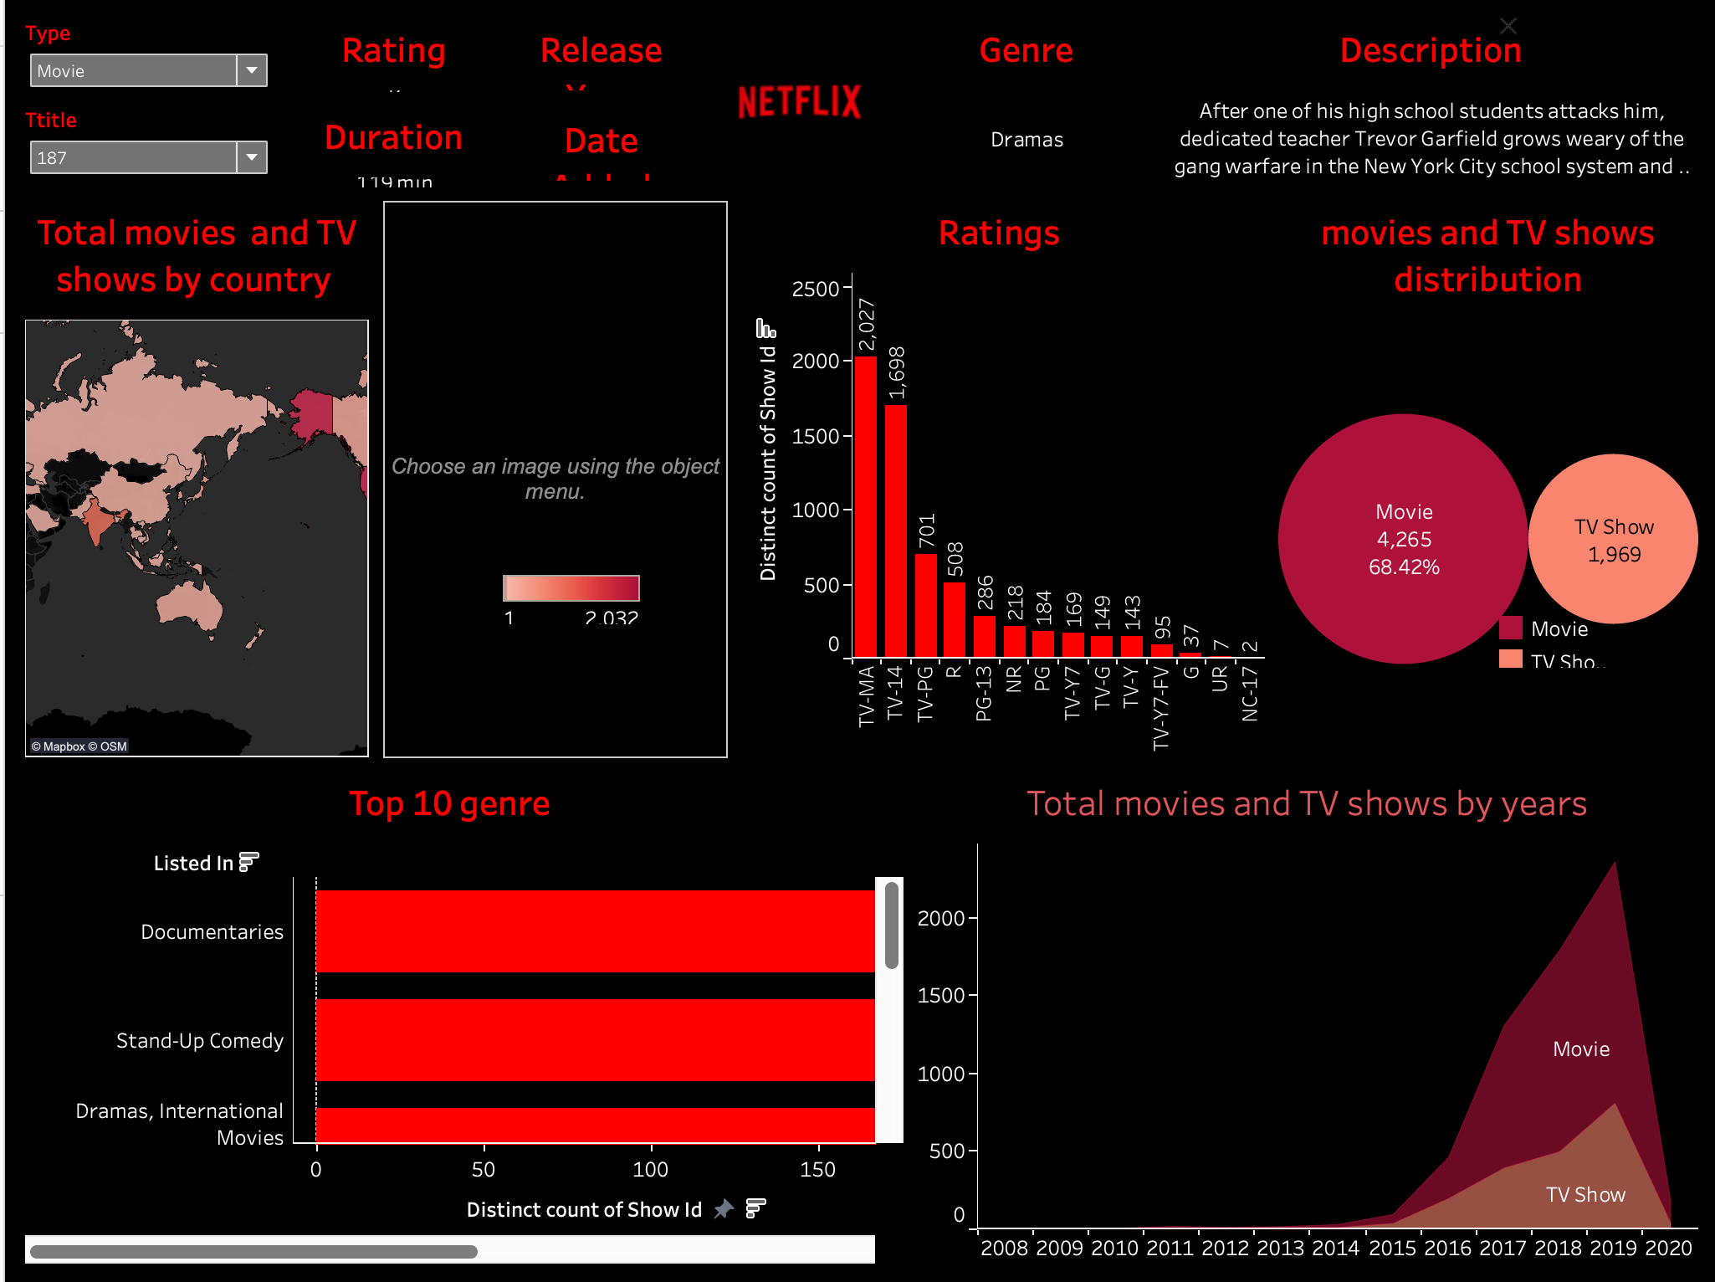

**Storyboards**

**Area Chart - Shows on Netflix Over a Period of Time**

This chart shows how the number of movies on Netflix grew much faster than TV shows from 2008 to 2020. This chart has time on the horizontal axis (X-axis) and the volume of content on the vertical axis (Y-axis) Movies have been increasingly popular over time, and this has helped marketers and content creators better grasp the tastes of their audience and the increasing demand for cinematic material on streaming services. This is important for people in the movie business to see how popular movies are on Netflix, which could help them think about what types of shows or movies they should make or sell to Netflix.

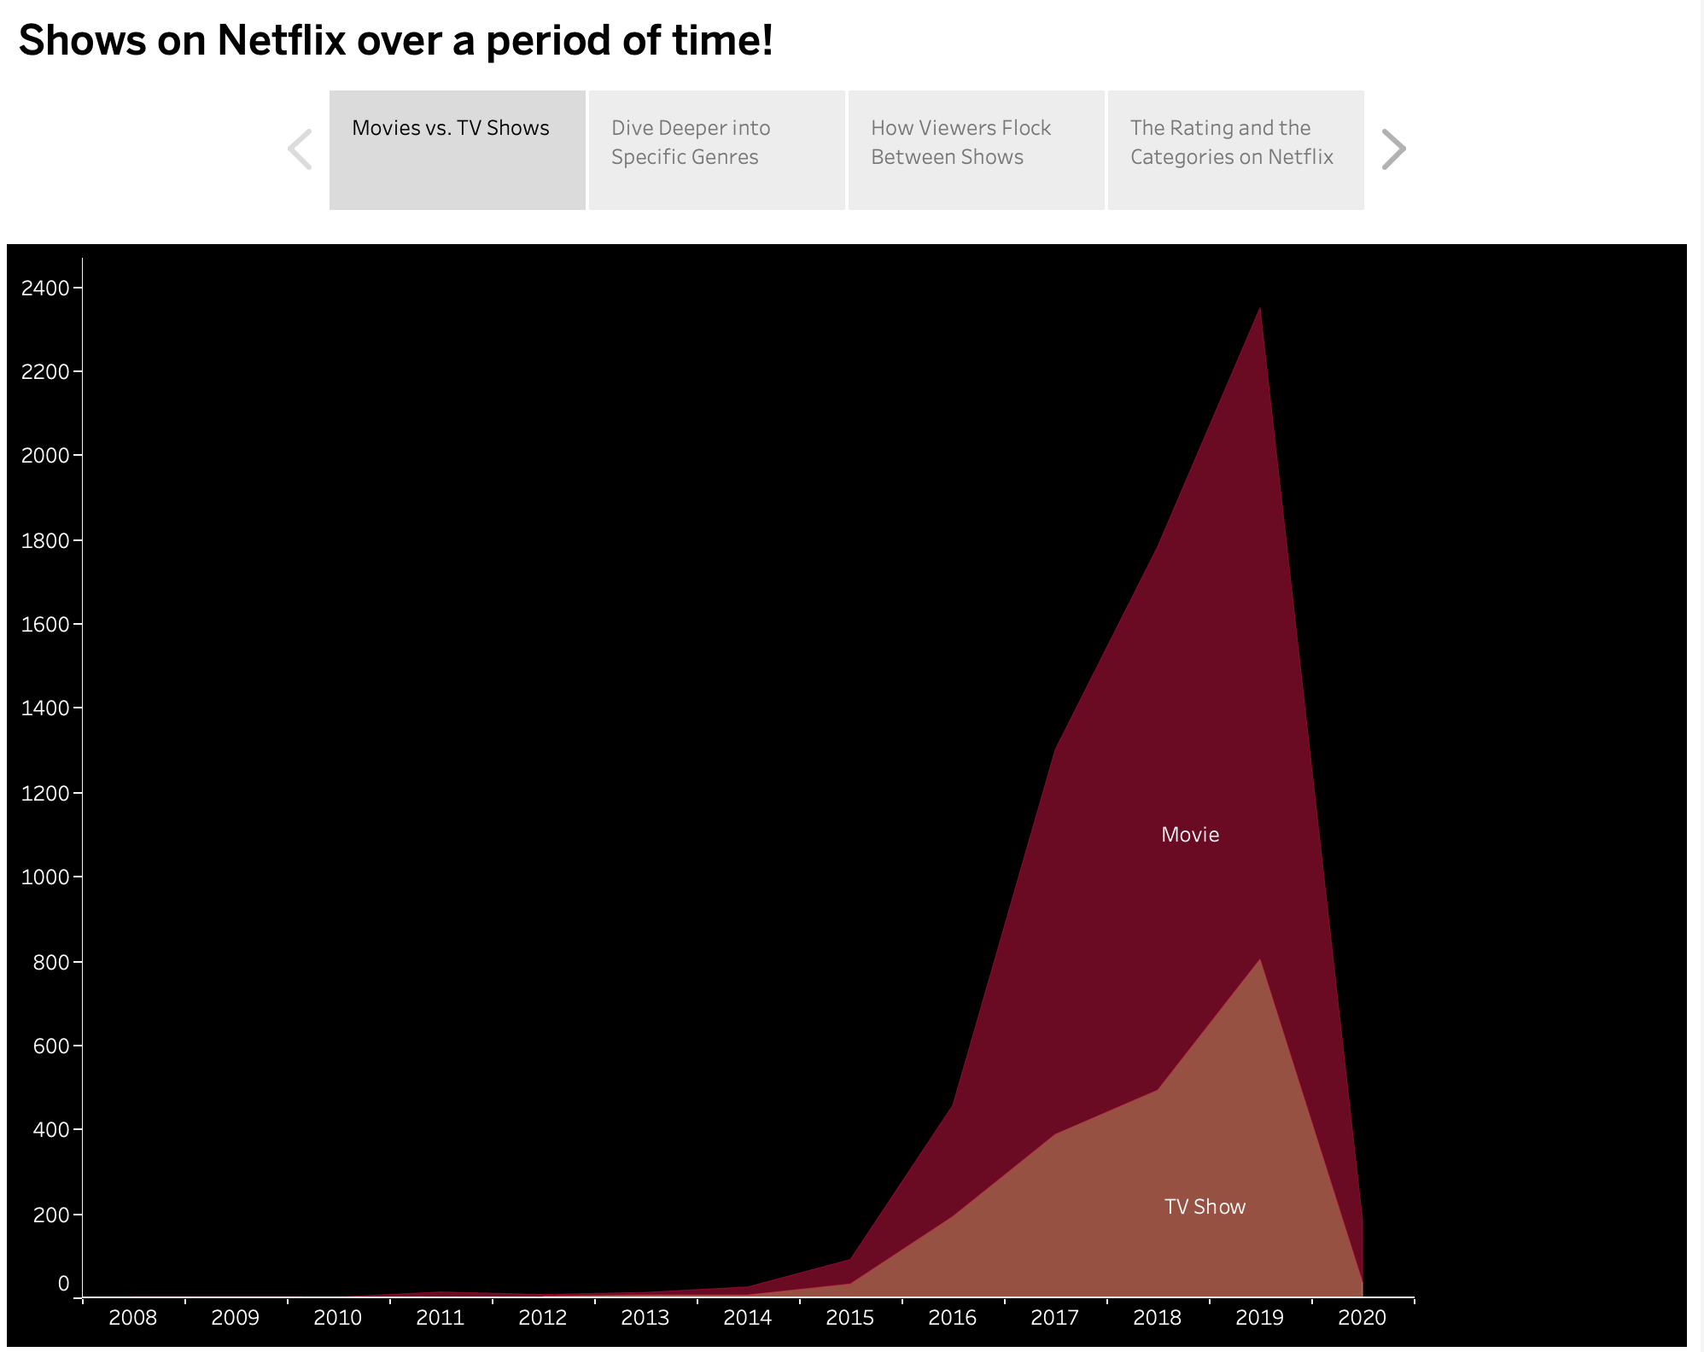

**Dive deeper into Genres:**

The genre distribution chart story employs a horizontal layout, with genres listed on the Y-axis and the count of titles on the X-axis. Documentaries and stand-up comedy genres lead, suggesting a stronger audience interest in these areas. This info is handy for folks who make TV shows or movies because it shows what kinds of content people like to watch, so they might want to make more of these.

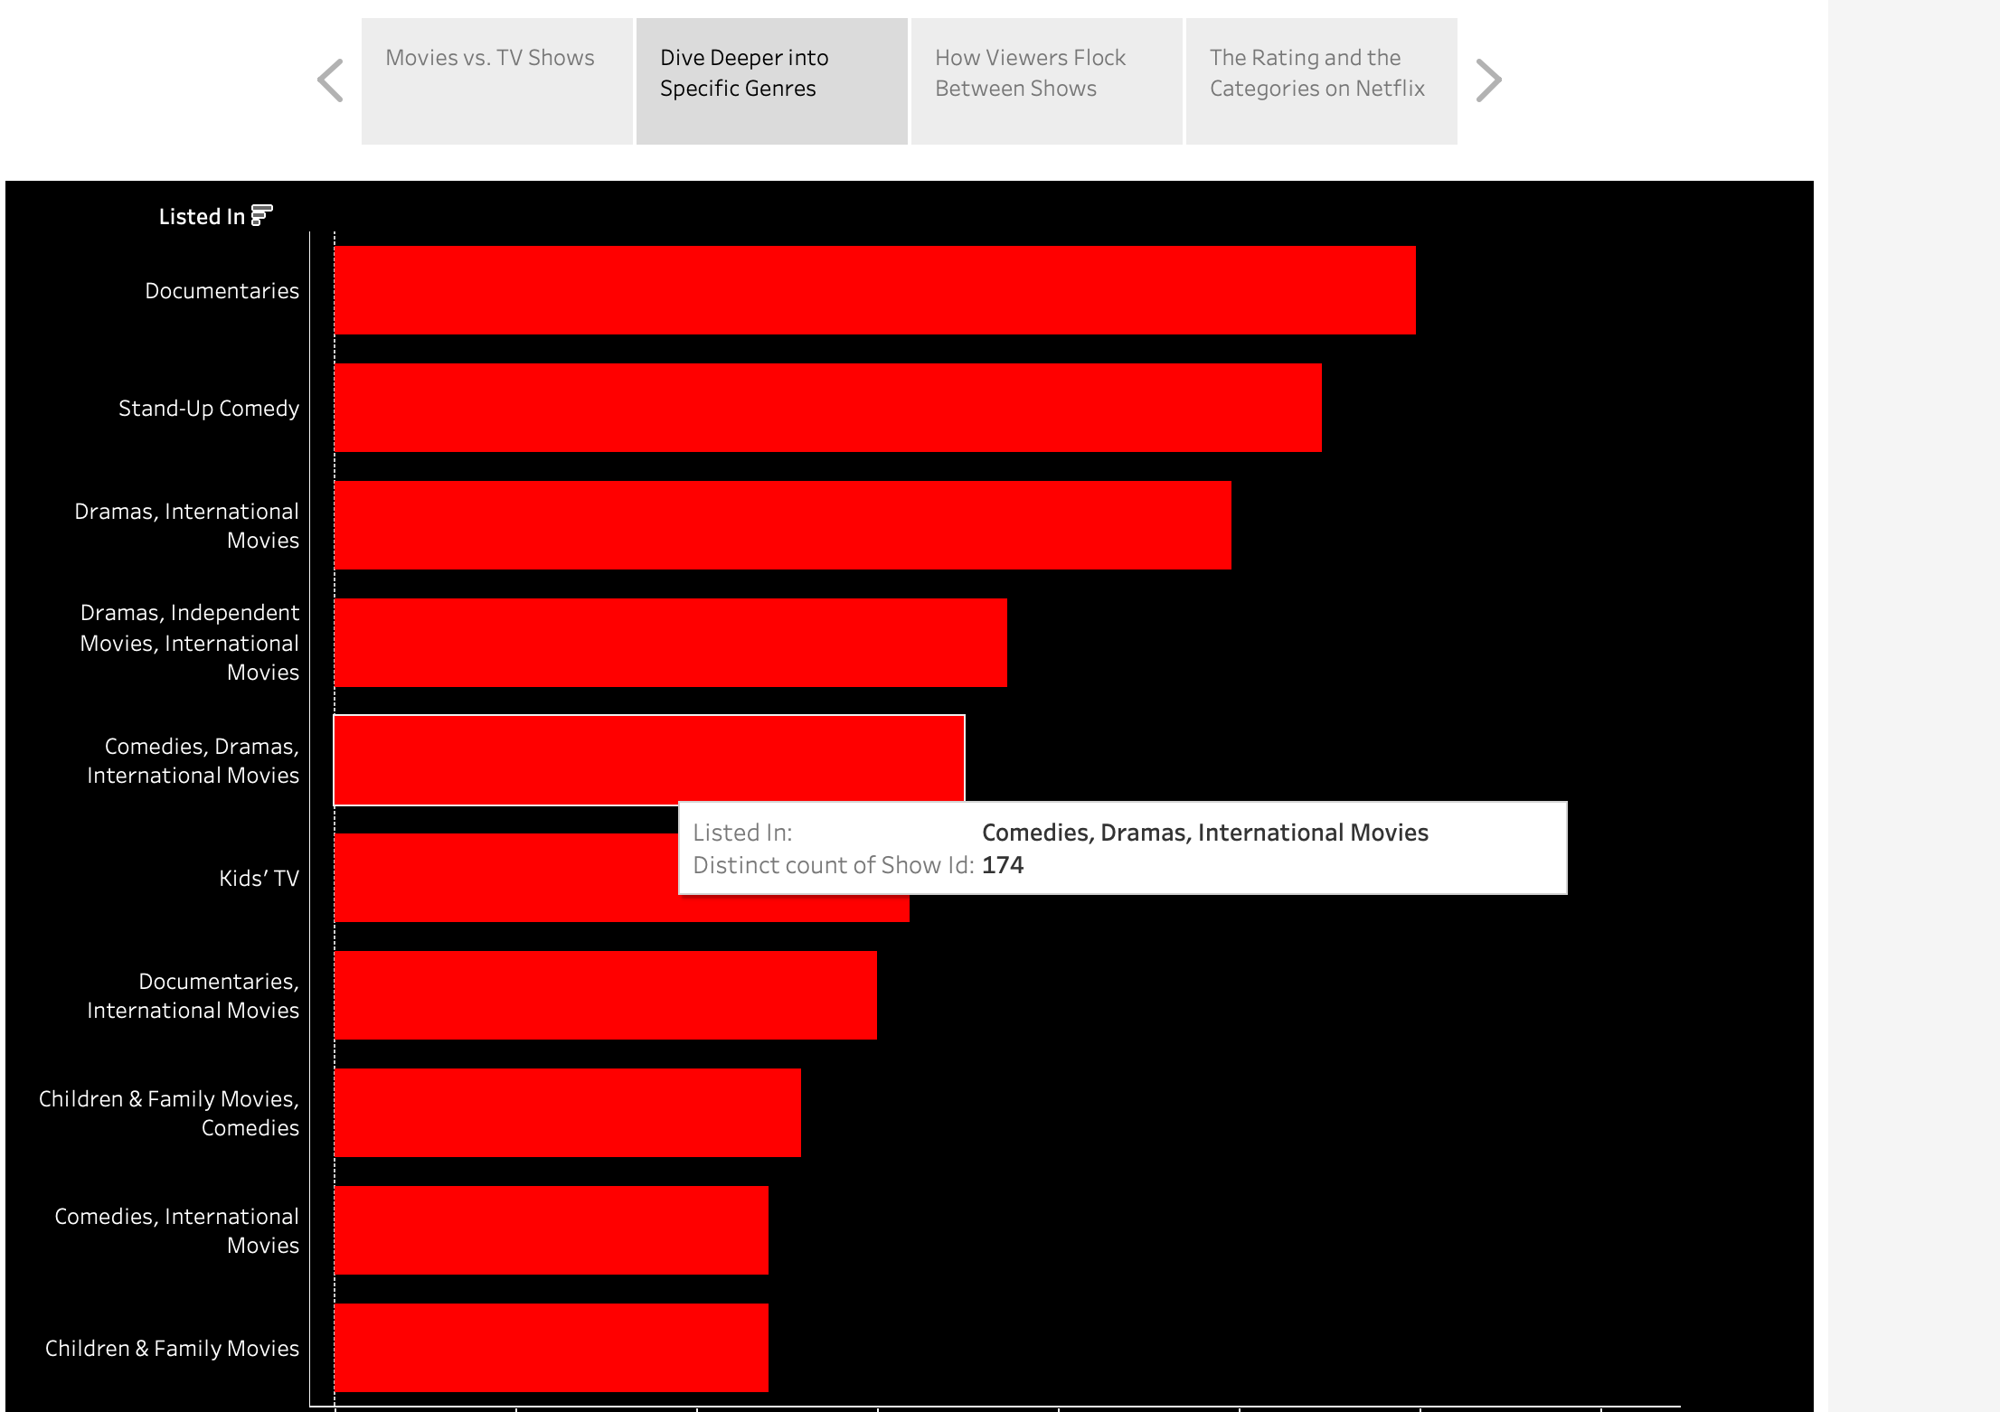

**How viewers flock between shows (Pie Chart):**

This story of bubble chart shows that there are a lot more movies than TV shows on Netflix. This tells the people who pick what shows and movies Netflix offers that they have been adding a lot more movies. They can use this information to decide if they should keep adding more movies or start adding more TV shows to give viewers a better mix.

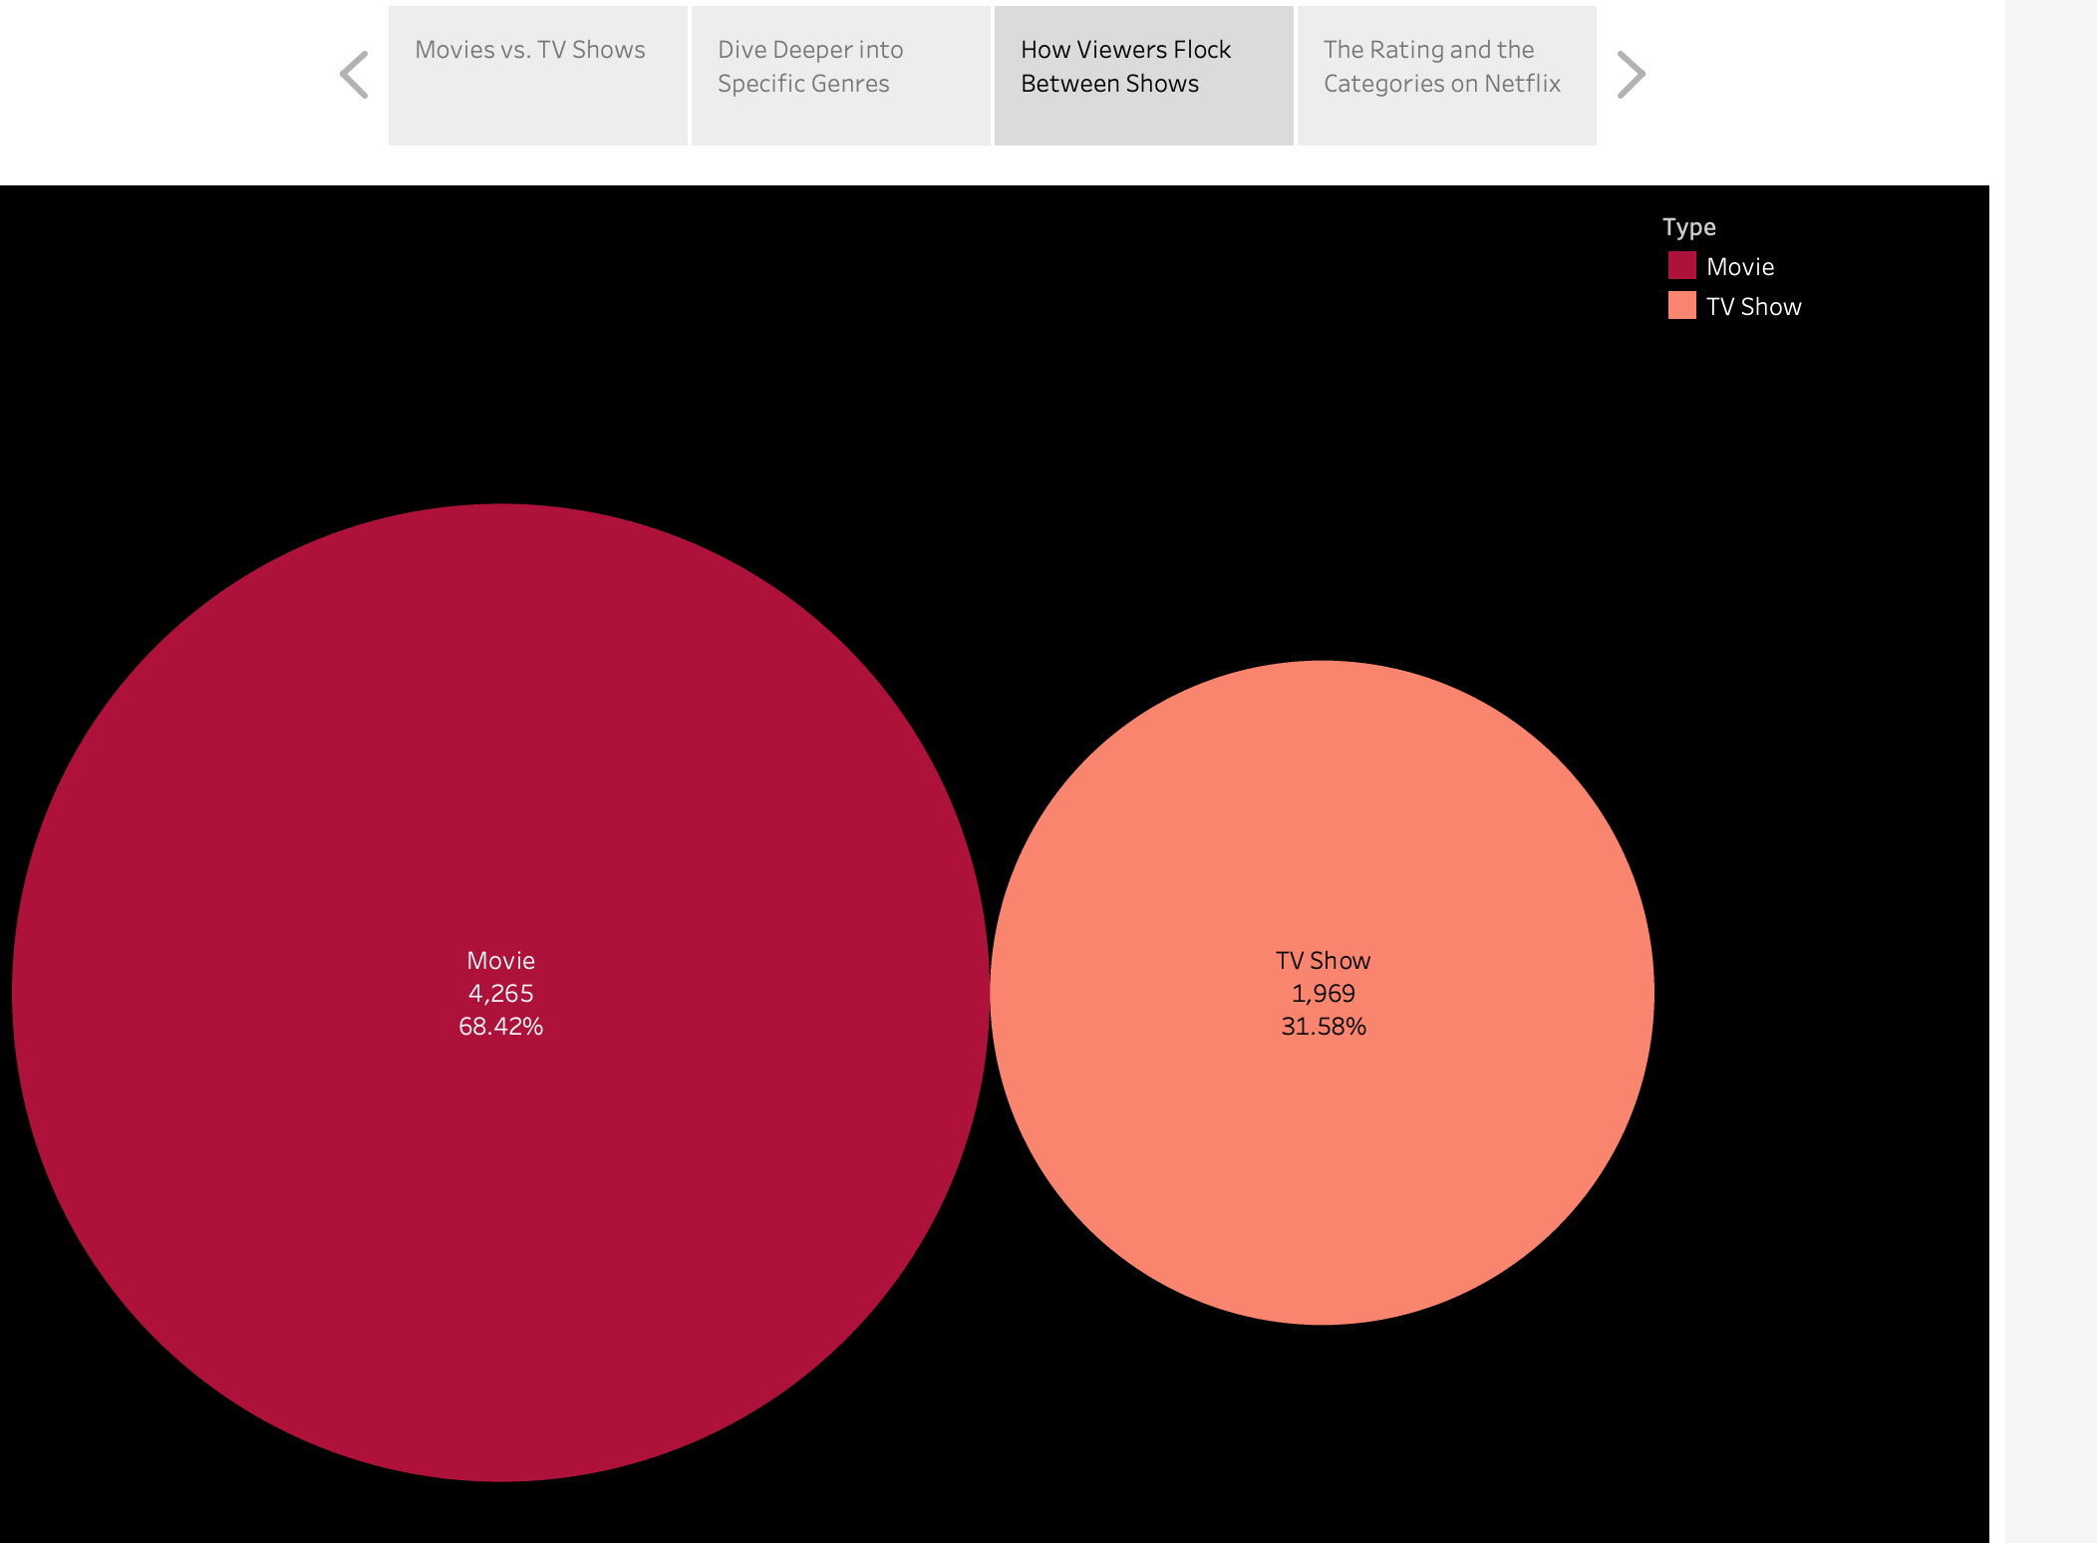

**Ratings and categories on the Netflix:**

The chart with different ratings like TV-MA and TV-14 tells us that most of the shows on Netflix are for adults. This is good for the people who manage what shows go on Netflix to make sure they have a mix of shows for everyone, from kids to adults.

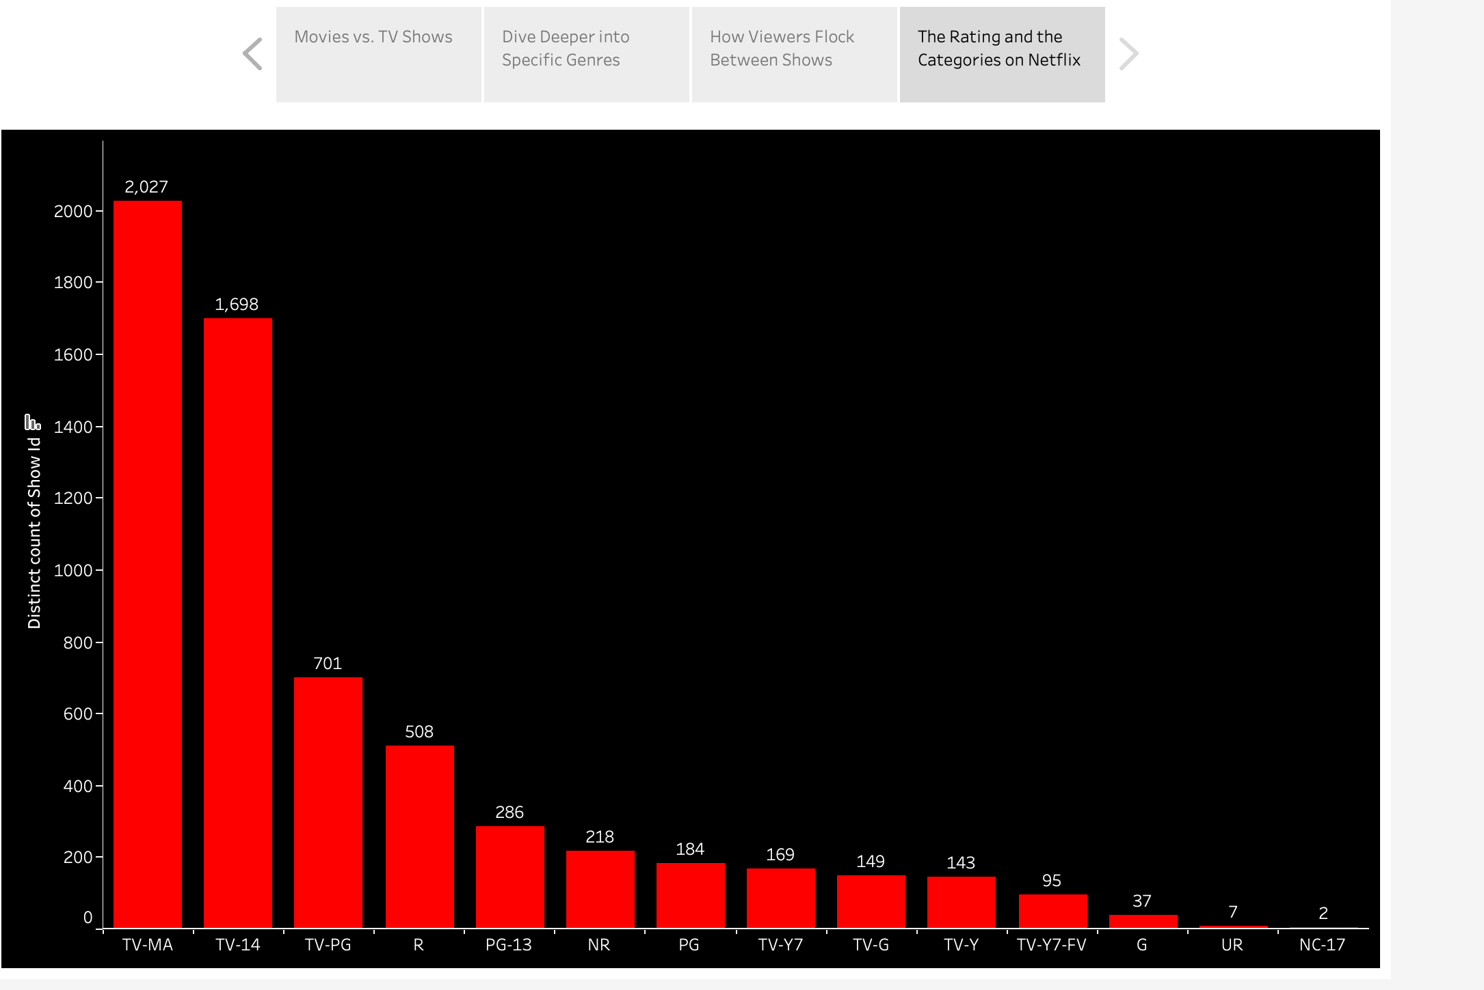

**Conclusion**

In conclusion, analyzing Netflix's data with Tableau allowed us to observe several very significant trends, such as the sheer volume of movies available and the most popular series. It's an excellent resource for using graphs and charts to make difficult material understandable. Anyone who has to decide what kind of content to generate or offer on streaming platforms, such as Netflix's programming teams and film and television creators, can greatly benefit from this type of analysis.

**References**